Physical Layer and Media (Part 2)

Signals

1. T is a function that represents the variation of a physical quantity with respect to time.
2. Example: Variation in temperature of a city in one day i.e. 24 hours
3. Analog signal and digital signal
4. Types:
   1. Analog signal:
      1. It is the signal that can take any value in the defined range
      2. All real life signals are analog in nature.
      3. 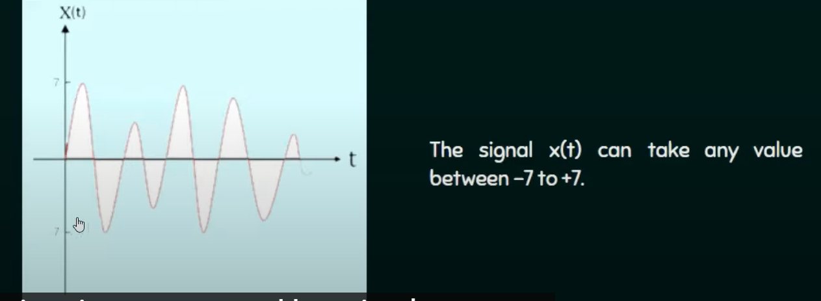
   2. Digital signal
      1. It is the signal that can take on of the finite values at any given time
      2. In case of digital signals we discretize both time and magnitude
      3. 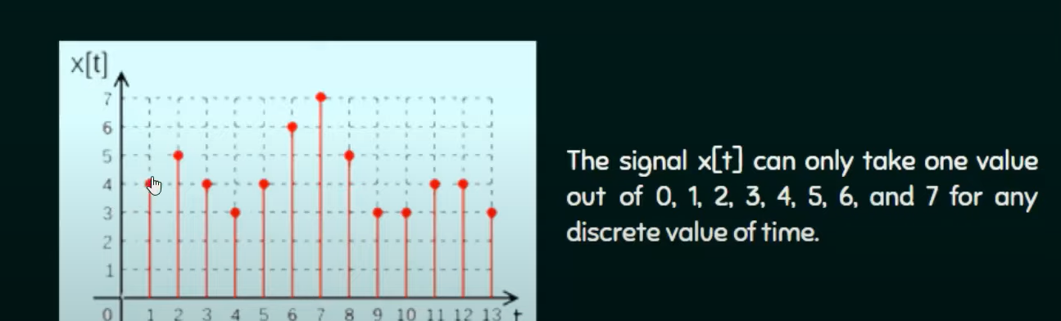

Physical Layer Media